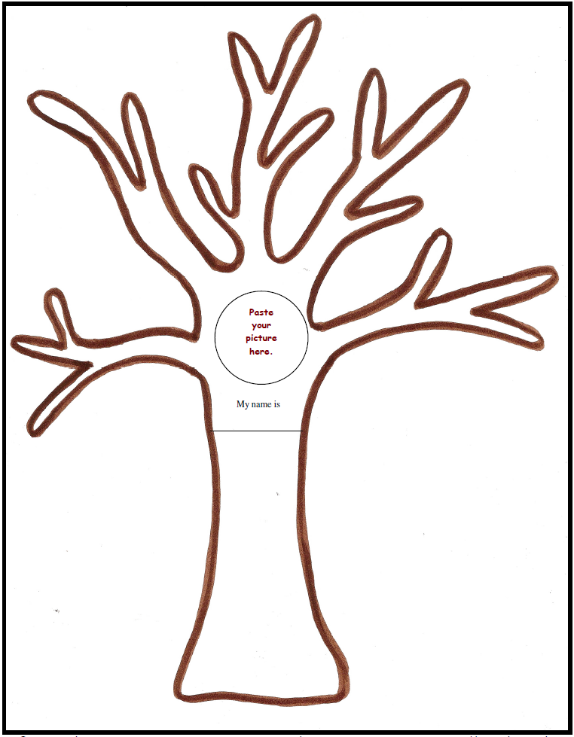

Directions:
- Color the background blue.
- Draw grass and/or flowers.
- Color the tree brown.
- Color and cut out the leaves. Trace more leaves on white paper, if needed.
- Glue photographs on the tree and leaves. (You will be inside the tree and your family will be on the leaves. Don’t forget your pets. If you don’t have a photograph, you can draw a picture.)
- Put the tree in the envelope and return it to your teacher.
- Your family tree will be put in your end of the year Memory Book.


